Reality Math
Dot Sulock, University of North Carolina at Asheville

World Oil II

1. US Oil Imports

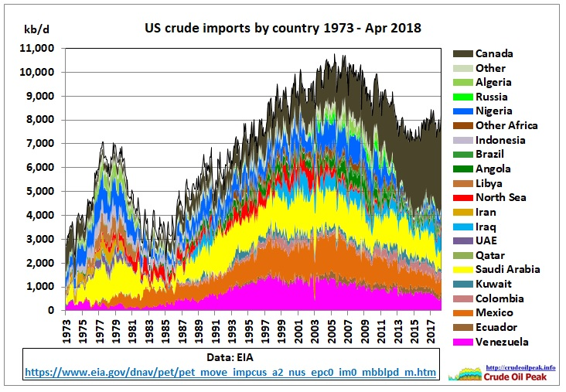

- (a) What nation was our number one oil supplier in 2019?

(b) About how much oil did our biggest supplier provide each day? kb/d is thousand barrels/day. Give answer in mb/d.

(c) Which three nations were essentially tied for second, third, and fourth suppliers?

(d) How much oil in total were we importing at the end of this graph? Give answer in mb/d.

2. World Oil Prices

From OIL-PRICE.NET http://www.oil-price.net/ Downloaded June 1, 2019

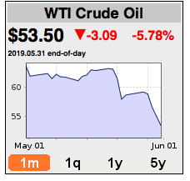
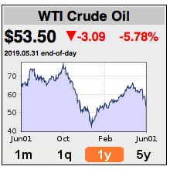

- (a) What is the price of WTI crude oil per barrel June 1, 2019?

(b) Give the increase or decrease from yesterday’s price and specify which it is (change in red is a decrease and change in green is an increase).

(c) What was May 31’s price ?

(d) According to the website, by what percent did the price increase or decrease since yesterday?

(e) Check the website percentage increase or decrease in price.

(f) What was the price one year ago?

(g) What was the percentage decrease in price from the maximum in Oct 2018 to the minimum in January 2019?

- (a) From the US Crude Import graph and using today’s price per barrel, about how much money is being sent out of the US to pay for our imported oil June 1, 2019?

(b) If oil always sold for the June 1, 2019 price, what would the annual cost of imported oil for the US.
3. Per Capita Oil Consumption (regions 2015, world 2019)

Country | Million barrels  per day - oil | Population  millions | Per capita oil consumption
United States | 19.9 | 327 | (a)
China | 13.3 | 1,386 | (b)
India | 4.7 | 1,339 | (c)
European Union | 15.0 | 513 | (d)
World Total | 100 | 7,700 | (e)

4. (a) – (e) Find the per capita oil consumption for each region. Round to nearest thousandth.

5 (a) The United State consumes what percent of world oil consumption?

(b) The United States is what percent of world population?

- (a) If the European Union had the same per capita oil consumption rate as the United States, how many mb/d would they consume?

- If India had the same per capita oil consumption rate as the United States, how many mb/d would they consume?

- If China had the same per capita oil consumption rate as the United States, how many mb/d would they consume?

- EU oil consumption would be how much higher?

- Indian oil consumption would be how much more?

- Chinese oil consumption would be how much higher?

- World oil consumption would be how much higher just counting the increases in these regions and forgetting all the other countries?

- If China, India, and the European Union all consumed as much oil per person as the United States, what would the World Consumption rate be?

- How long would the 1,665 trillion barrel world oil reserves last at this new rate? Give your answer in days and years

- A country is a net-importer of oil if it uses more oil than it produces. A country is a net-exporter of oil if it produces more oil than it uses.
Is the United States a net-importer or net-exporter of oil?

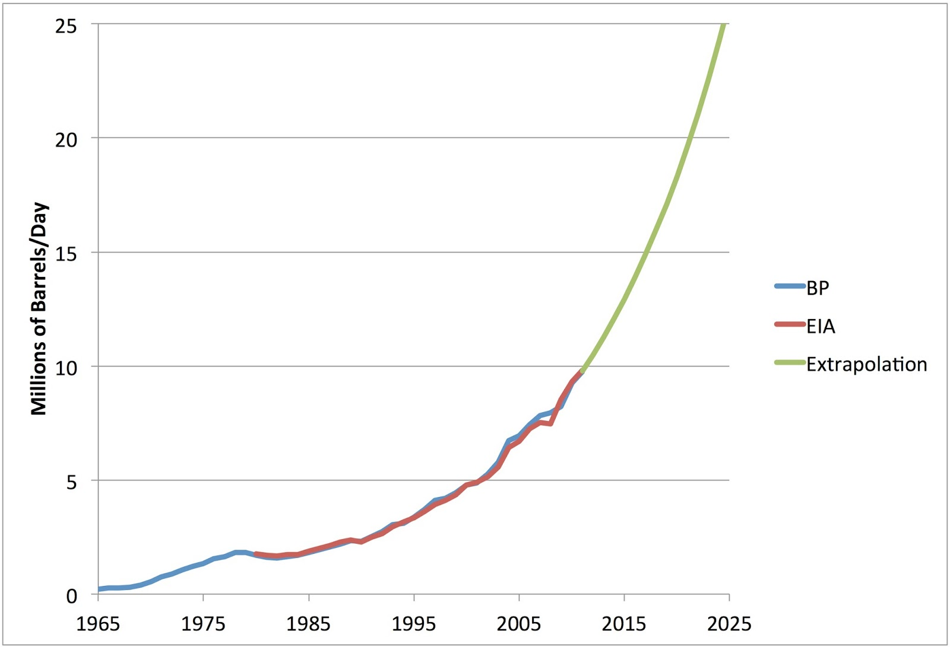

- (a) Estimate the percentage increase in Chinese oil consumption from 2010 to 2025 using the “extrapolation.”

(b) Is the “extrapolation” pretty accurate for 2015? Compare to table on page 3.

(c) About what year will China reach the US 20 mb/d?

(d) US Oil consumption is now fairly level. Do you think Chinese oil consumption will level off soon? Explain.

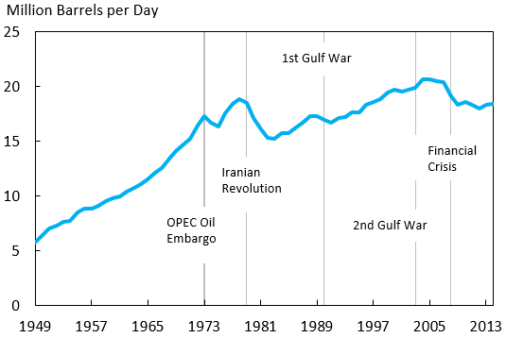

10. Reflect. Explain why these numbers matter.

