Sugar Math - 1

The average American adult consumes about 355 calories of added sugar = 22.2 teaspoons each day. That is about triple the recommended amount (1).
(1) One teaspoon of sugar has about how many calories?
(2) What amount of calories of added sugar are recommended for an adult each day?
(3) How many teaspoons of added sugar should an adult be eating each day?

Cinnamon Toast Crunch has 10 grams of sugar per serving. A serving size is ¾ of a cup. Each gram of sugar has about 4 calories.

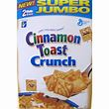

(4) The sugar in a serving of Cinnamon Toast Crunch has how many calories?
(5) How many teaspoons of sugar are in each serving of Cinnamon Toast Crunch?
(6) How many teaspoons of sugar are in 1 ½ cups of Cinnamon Toast Crunch?

A Frosted Cherry Pop Tart has 17 grams of sugar in it.
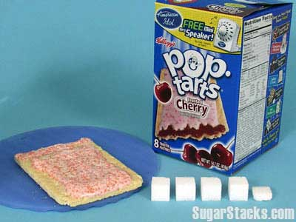
(7) How many teaspoons of sugar does a Frosted Cherry Pop Tart have?
(8) Three Frosted Cherry Pop Tarts have about as much sugar as how many servings of Cinnamon Toast Crunch?
(9) Three Frosted Cherry Pop Tarts have about as much sugar as how many cups of Cinnamon Toast Crunch?

Pre-teens eating 1,800 to 2,000 calories per day should be eating 5 to 8 teaspoons of added sugar per day.
(10) If you are a pre-teen and eat a Frosted Cherry Pop Tart for breakfast, how many more teaspoons of added sugar should you eat that day?
_______________
1. American Heart Association guidelines. http://life.familyeducation.com/nutritional-information/obesity/64270.html

