Sugar Math – 3

1. Pre-teens should be eating from ______ to _____ teaspoons of sugar per day to be healthy and strong.

1 teaspoon sugar = 16 calories = 4 grams

2. Here is a Gatorade nutrition label. What’s in Gatorade? _____________________________
_______________________________________________________
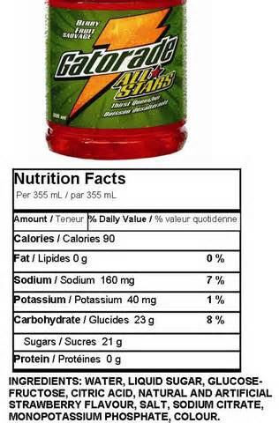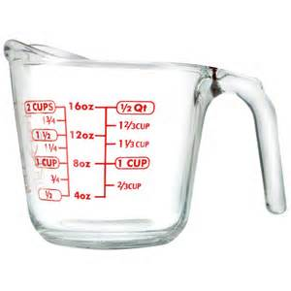

3. How many teaspoons of sugar are in this Gatorade? ____________________
4. If a pre-teen drinks one of these Gatorades, how many addition teaspoons of added sugar should be in her desserts, breakfast, and snacks that day?

Let’s see how much Gatorade this is.

- A liter is about a quart
- A quart is 4 cups
- A liter is 1000 mL

5. A cup is about how many mL? ________________
6. A cup is about how many ounces? ________________
7. 12-ounces is about how many mL? _______________

8. About how many grams of sugar should a pre-teen eat or drink each day?

9. A 12-ounce MacDonalds McCafe Chocolate Shake has 91 grams of sugar.
How many teaspoons is 91 grams of sugar? _________________________

