Sugar Math -2

The average American adult consumes about 355 calories of added sugar = 22.2 teaspoons each day 1.
1 tsp sugar
=
__________
calories

Pre-teens eating 1,800 to 2,000 calories per day should be eating 5 to 8 teaspoons of added sugar per day.

2. Pre-teens should eat about how many calories of added sugar each day?

1 gram of sugar = 4 calories

3. Pre-teens should eat about how many grams of added sugar each day?

This is the nutrition label for a can of Coke

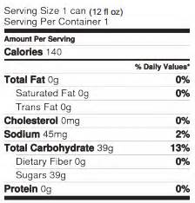

4. All of the calories in a Coke come from added sugar. How many teaspoons of sugar in one can of Coke?
5. Protein is the building block ingredient for your body. How many grams of protein does a Coke have?
6. If a pre-teen has one Coke each day, how many teaspoons of the recommended added sugar amount are left for breakfast cereal, dessert, and snacks?

