Keeping 4th Grade Bodies Strong

Carrot Nutrition

Daily Calories for 9 - 13 Year-Old Girls

Inactive 1600
Moderately active 1800
Active 2000

Daily Calories for 9 - 13 Year-Old Boys

Inactive 1800
Moderately active 2000
Active boys 2300

The American Heart Association recommendations:

Total fat intake About 30% of total daily calories

Children at this age need every day:
3 cups of fat-free or low-fat milk or equivalent
5 oz. lean meat or beans
1 1/2 cups fruit
2 cups vegetables and 5 oz. grains for girls
2 1/2 cups vegetables and 6 oz. grains for boys

Read more: http://www.livestrong.com/article/270952-how-many-calories-should-a-9-year-old-have-daily/#ixzz2eKGpKLKI
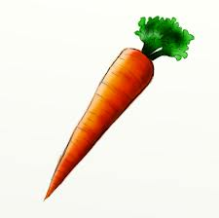

Nutrition Facts
Serving Size 1 cup of chopped carrots
Amount Per Serving
Calories from Fat 3
Calories 52

A Carrot Equals
There is 3/8 Cup (79 mls) of Carrot Shredded in a Carrot

There is ½ Cup (118 mls) of Carrot Sliced in a Carrot

There is ½ Cup (158 mls) of Carrot Chopped in a Carrot

http://www.howmuchisin.com/produce_converters/carrot

1. How many carrots does it take to make 1 cup of chopped carrots?

2. A carrot has how many calories?

3. Lebomb is in 4th grade and on Friday he decides to get all of his needed veggies from carrots. How many carrots should he eat on Friday?

4. Do you think that carrots are a high-fat food or a low-fat food? Circle one: high-fat low-fat

