Keeping 4th Grade Bodies Strong

Apple Nutrition

Daily Calories for 9-Year-Old Girls

Inactive 1600
Moderately active 1800
Active 2000

Daily Calories for 9-Year-Old Boys

Inactive 1800
Moderately active 2000
Active boys 2300

The American Heart Association recommendations:

Total fat intake About 30% of total daily calories

Children at this age need every day:
3 cups of fat-free or low-fat milk or equivalent
5 oz. lean meat or beans
1 1/2 cups fruit
2 cups vegetables and 5 oz. grains for girls
2 1/2 cups vegetables and 6 oz. grains for boys

Read more: http://www.livestrong.com/article/270952-how-many-calories-should-a-9-year-old-have-daily/#ixzz2eKGpKLKI
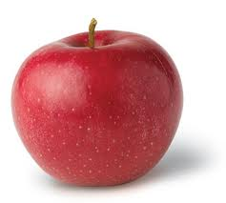

Nutrition Facts
Serving Size 1/2 cup apple slices
Amount Per Serving
Calories from Fat 1
Calories 29

1. ½ cup of apple slices has how many fat calories?____

2. How many non-fat calories in ½ cup of apple slices?____

3. Slicing up one apple makes 1 cup of apple slices. How many ½ cup servings of apple slices equal one apple?_____

4. Jose is a 9-year old boy. He wants to eat all apples for his fruit on Monday. How many of these ½ cup apple servings should he eat on Monday?______

5. How many fat calories will three ½ cup servings of apples contain? ________

6. How many calories will three ½ cup servings of apples contain? _______

7. Would you say that apples are a high-fat food or a
low-fat food? Circle your choice: high-fat low-fat

